**CS3506 Lab 1 - Wireshark UDP/DHCP - Assignment**

NAME: __Alexander Stradnic__________________

STUDENT NUMBER: __119377263_____________

**1. UDP**

* 1. Select one UDP packet. From the packet content field, identify and determine the length (in bytes) of each of the UDP header fields.

2 Bytes : Source Port, Destination Port, Length, Checksum

51 Bytes : UDP Payload

* 1. The value in the Length field is the length of what? Verify your claim with your captured UDP packet.

The value in the Length field is the length of the packet in bytes, as adding up the Source, Destination, Length, Checksum and Payload equals 59 bytes, which is the Length value.

* 1. Input to the network interface is zeroes and ones. How does it know where the next frame starts? Based on the headers you see (Ethernet, IP, UDP), what is the maximum frame size?
  2. Based on information in the UDP header alone, what is the highest possible source port number? Explain your answer.

The highest possible port number is 2^16 – 1, based on information in the UDP header. The UDP header assigns 2 bytes, or 16 bits, to the source port number. Thus it follows that the highest port number is the highest number possible to store in 2 bytes, which is 2^16 -1.

* 1. Examine a pair of UDP packets in which the first packet is sent by your host and the second packet is a reply to the first packet. Describe the relationship between the port numbers in the two packets.

When the packet is sent from the host on port 49461, the port is the source, and 53 is the destination port. In the response packet, the source and destination are reversed.

* 1. Consider a system using Ethernet/IP/UDP, with a maximum Ethernet Frame size of 500 bytes + the three last digits of your student number. What is the maximum number of bytes of UDP payload supported?

Max Eth Frame Size = 500 bytes + 263 bytes = 763 bytes

Max number of bytes in Payload = 763 bytes – 42 bytes for headers = 721 bytes.

1. **DHCP**
2. Draw a time sequence diagram illustrating the first four-packet Discover/Offer/Request/ACK DHCP exchange between the client and server. For each packet, indicate the source and destination port numbers. (Do not simply copy and paste this from another source).

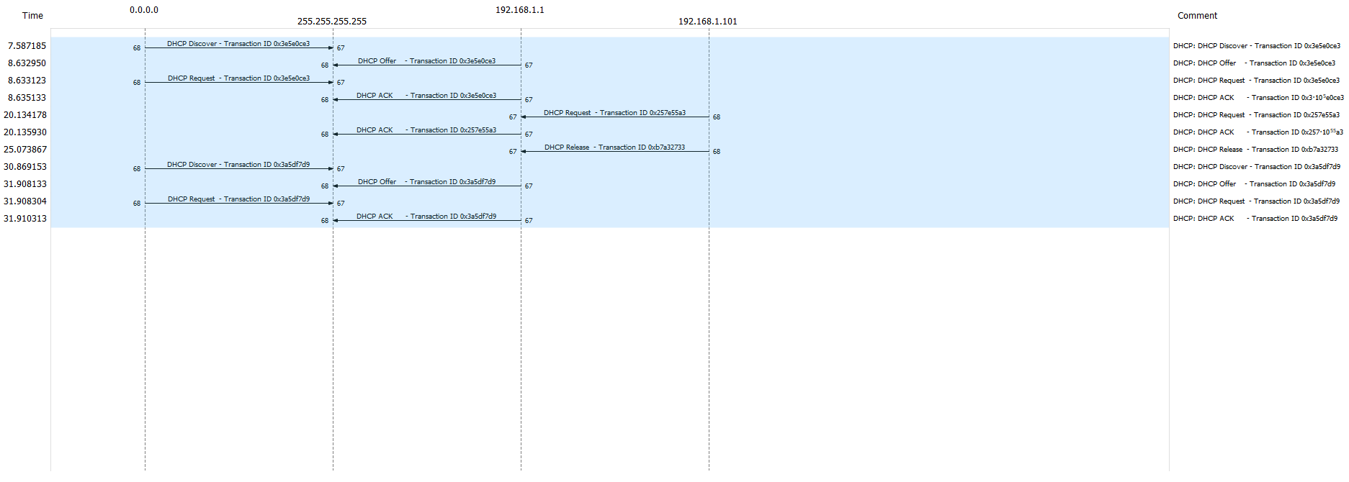

Discover packet source: 68, destination: 67

Offer source: 67, destination: 68

Request source: 68, destination: 67

ACK source: 67, destination: 68

1. What is the link-layer (i.e., Ethernet) address of the host sending the DHCP Discover message?

Host Ethernet Address: Dell_4f:36:23

1. What is the purpose of having a DHCP discover and a DHCP request message? (Why are they both needed?)

Discover looks for a DCHP server to contact, and then the Request message asks for an IP address.

1. What is the purpose of the Transaction-ID field?

It is used to identify the specific request.

1. A host uses DHCP to obtain an IP address, among other things. But a host’s IP address is not confirmed until the end of the four-message exchange! If the IP address is not set until the end of the four-message exchange, then what values are used in the IP datagrams in the four-message exchange? For each of the four DHCP messages (Discover/Offer/Request/ACK), indicate the source and destination IP addresses that are carried in the encapsulating IP datagram.

Source Destination

Discover 0.0.0.0 255.255.255.255

Offer 192.168.1.1 255.255.255.255

Request 0.0.0.0 255.255.255.255

ACK 192.168.1.1 255.255.255.255

1. What IP address is the DHCP server offering to the host in the DHCP Offer message? Indicate which DHCP message field contains the offered DHCP address.

The host is being offered the 192.168.1.101 address, which is sent in the DHCP payload.

1. Explain the purpose of the router and subnet mask lines in the DHCP offer message.

The subnet mask is used to see if the host is in the local subnet or in a remote network.

The router communicates between the device and the rest of the network.

1. Explain the purpose of the DHCP lease time.

It assigns a dynamic IP address to a client for a set length of time.

1. What is the purpose of the DHCP release message? Does the DHCP server issue an acknowledgment of receipt of the client’s DHCP request? What would happen if the client’s DHCP release message is lost?

The release message is sent when the IP lease has expired. The server does not issue an acknowledgement of receipt of the client’s DHCP request; if it is lost, then it is lost.